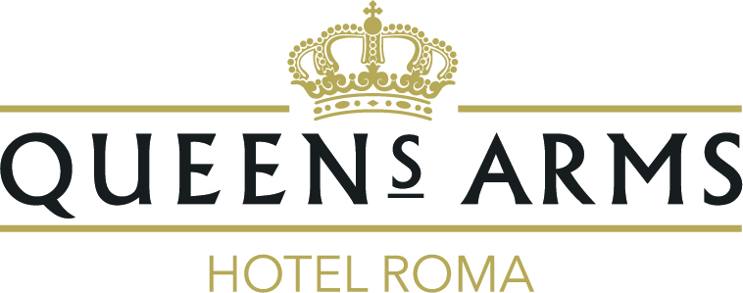

Community Benefits Program – Round 1
Winter 2018
Our staff and customers know that rural Queensland is a diverse and dynamic place to live, work and visit and the Queens Arms Hotel Roma is proud to support grassroots groups who are helping to make our local community even better!
The Queens Arms Hotel Roma Community Benefits Program is designed to build relationships with community organisations to provide benefits to locals and visitors by supporting and promoting our vibrant and active community. The program provides small one-off sponsorships and donations to a maximum of $2,500 per round (total in aggregate) to not-for-profit organisations based in Roma and the Maranoa region with the aim to support as many local groups as we can.
What we love! We want to focus on activities that contribute to one or more of the following areas in our community; Sport and Recreation, Education, Environment, Health and Arts and Culture
The Rules…
- Your organisation must be a not-for-profit organisation providing services in Roma and the Maranoa Local Government area
- The project must be delivered in and/or directly benefiting Roma and the Maranoa Local Government area
- The project must be for a one-off community project, service or event (make sure you check the open and close dates and apply prior to your event)
Stuff we won’t fund:
- Activities that do not directly benefit our community in Roma and the Maranoa
- Political contributions, business memberships and requests from religious organisations for religious purposes
- Ongoing costs or retrospective project costs
- Activities which may be considered disruptive to the community
- Activities which don’t align with The Queens Arms Hotel Roma’s values
Dates you need to know:
The Queens Arms Hotel Roma Community Benefits program will accept applications for sponsorship and donations from 15th June 2018 until 15th August 2018] with successful organisations being notified within 3 weeks of the close date.
Applying:
If you believe your application is eligible, fill out the application form, sign the declaration and deliver it into the dedicated box in the QA during the dates above. Any questions? Please don’t hesitate to speak with our Manager Maureen in the QA.

Community Benefits Fund
Application Form
Organisation name
Address
ABN
Incorporation | Please attach a copy of your incorporation certificate
Project contact person
Position held
Phone |  |  | Mobile:
Email address
Bank details | Name
 | BSB |  |  | Account #

What type of support are you requesting? (please tick)

Sponsorship, one-off investment with an expectation of public recognition for The Queens Arms Hotel Roma’s support

Donation, one-off financial contribution without expectation of public recognition for The Queens Arms Hotel Roma’s support

Amount being requested up to $2,500
(Please note the fund is discretionary and you may not receive the full amount being requested, our goal is to support as many local organisations and groups as possible!)

Project name

Location

Briefly tell us about your project and what the funding will be used for?

Please include any dates for key milestone activities

How will your project benefit the community?

If your application is successful, how do you intend to acknowledge the Queens Arms Hotel Roma? (only for sponsorships)
e.g. Newsletter, Media Release, Social Media etc.

I hereby declare that all information I have provided on this application form is true and correct to the best of my knowledge.

Authorised organisation representative’s signature:

Name |  | Signed:
Position: |  | Date:

The fine print!

Tc’s and C’s
- The Queens Arms Hotel Roma Community Benefits Program is discretionary, to ensure we support a broad range of community organisations applicants may only receive partial funding for their project
- Only applications deemed eligible will be considered for funding
- Only organisations deemed eligible will be considered for funding
- Applications will only be considered when submitted during the funding open dates. Late applications will not be considered
- All payments made are gst inclusive.

